Sharing a Database With GPRM
A Windows installation of DerbyNet can use the same Access database as the Grand Prix Race Manager (GPRM) product by Lisano Enterprises; this allows web-based access to the data while still using GPRM. This is accomplished by defining the GPRM database as an “Open Data Base Connectivity” (ODBC) data source.
Note that you must update the ODBC data source whenever you change databases in GPRM.

Define an ODBC Data Source Name
In “Control Panel,” “Administrative Tools,” find the “Data Sources (ODBC)” management console. Choose the “System DSN” tab, and click the “Add…” button.

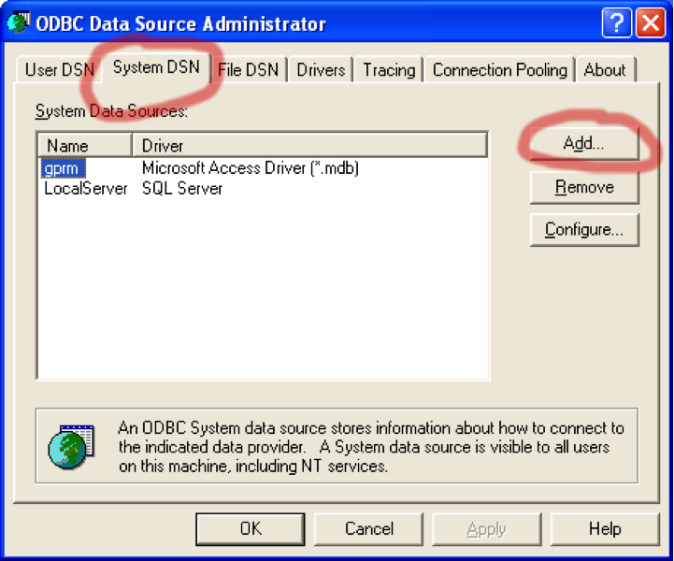
In the “Create New Data Source” dialog that appears, select “Microsoft Access Driver (*.mdb)” and click “Finish.”
Note: In some 64-bit versions of Windows (notably Windows 7, at least), the driver for Microsoft Access is available only in the 32-bit version of the ODBC Data Sources Administrator control panel. If you do not see an entry for “Microsoft Access Driver (*.mdb)” or similar, close the control panel and instead open C:\Windows\SysWOW64\odbcad32.exe. See http://support.microsoft.com/kb/2721825/EN-US.
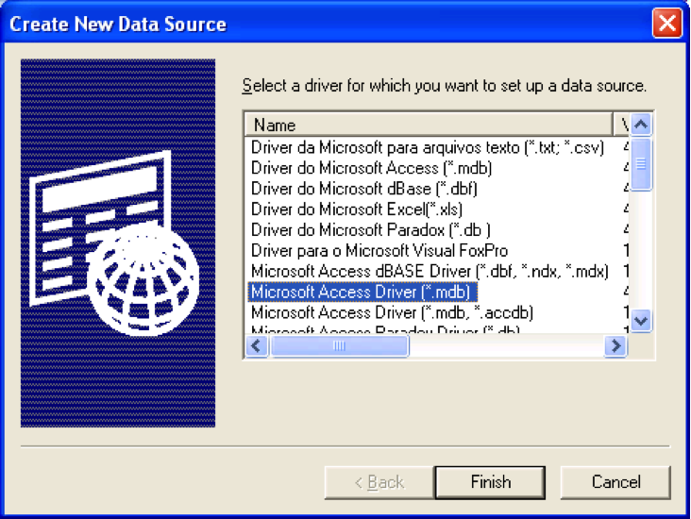
Next you’ll see the “ODBC Microsoft Access Setup” dialog. Enter “gprm” in the Data Source Name field (this is the name the scripts expect), and click the “Select…” button.
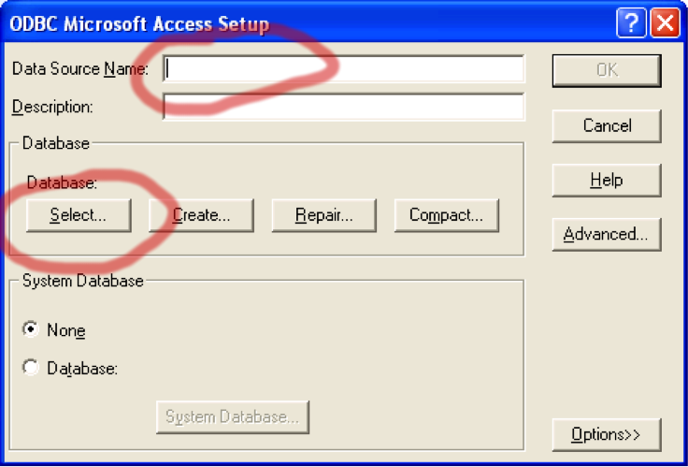
In the “Select Database” dialog, you have to select the actual database file you’re using for GPRM. By default, the path to this file is under “My Documents”, “Lisano Enterprises”, “GrandPrix Race Manager”, “Data” (at least in version 9 of GPRM).
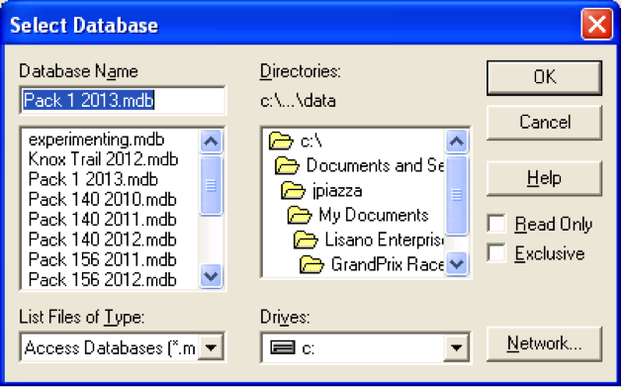
Changing the data source (as opposed to adding a new one) is similar; click the “Configure…” button instead of “Add…” from the ODBC Data Source Administrator window, and just select a new database file.

Set Up Database for DerbyNet
Now that you’ve set up your ODBC data source, you can configure DerbyNet to use the same database by following the steps described in “Advanced Database Set-Up for DerbyNet” document.

